Card 1. Приложение 2
1.Replace the full rejection of the brief. Swipe the arrow. (Замените полное отрицание – кратким. Проведите стрелку.)
Parrot cannot skip. | Isn’t
The cat is not green. | Hasn’t
Ann has not got frog. | Can’t
A dog cannot fly. | Hasn’t
The pencil is not long. | Can’t
Fox has not got hat. | Isn’t

2. Record the following positive sentences negative.
Tiger can swim.
Monkey has got hen.
Cat is fat.
Mouse can sing.
Pencil is grey.
Mother has got lion.

3. Think of the negative images offer.
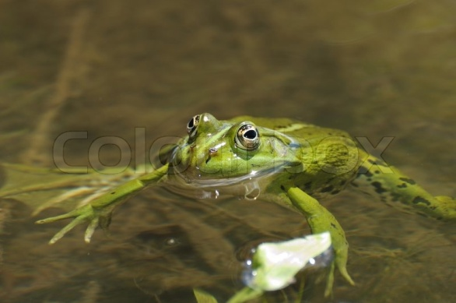

Приложение 4
can | cannot | can’t
has got | has not got | hasn’t got
is | is not | isn’t

Приложение 5
It was very easy and clear | I need more practice | I had a very hard perform the job

